Manufacturing & Supply Chain Analytics Report

1. Business Problem Statement
Manufacturing Automotive (OEM) organizations operate complex multi-plant production systems where inefficiencies in production, quality, inventory, and supplier performance can significantly impact cost, delivery timelines, and customer satisfaction.
The objective of this project is to:
- Monitor production performance
- Identify quality and defect trends
- Assess inventory risk
- Evaluate supplier lead-time reliability
- Enable data-driven decision-making for plant managers and executives

2. Data Overview
The dataset consists of 693+ production and supply chain records representing multi-plant manufacturing operations across time, shifts, and suppliers.

Data Sources
- Manufacturing production records
- Quality & defect logs
- Inventory and supply chain data
- Supplier lead time data
- Downtime and root cause data

Key Tables / Fields
- units_produced, planned_units
- production_efficiency, raw_material, downtime_minutes, downtime_reason
- defective_units, defect_type, inventory_level
- supplier_id, lead_time_days, reorder_level
- plant_id, production_date, shift, delivery_delay_days

3. Data Cleaning & Transformation

Tools Used
- Google Sheets
- PostgreSQL (pgAdmin4)
- Python(pandas, numpy)

Key Transformations
- Converted text-based date fields to Date data type
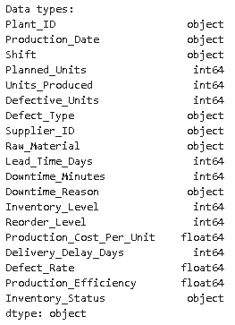
- Removed null and invalid production records
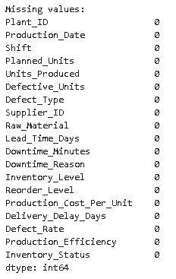
- Derived analytical metrics such as Defect Rate, Production Gap, and Inventory Status using SQL and DAX to ensure consistency across reporting layers.
- Standardized percentage metrics for consistency
- Ensured plant-level granularity for drill-down analysis
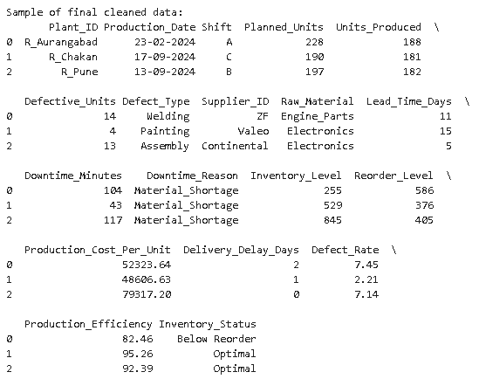
4. Data Modeling
- Star-schema-style logical model
- Central fact table: Manufacturing Production
- Dimensions:
  - Plant
  - Supplier
  - Date
  - Defect Type
  - Downtime Reason
This modeling approach ensures accurate aggregations, simplified KPI calculations, and scalable analytics aligned with enterprise BI best practices.

⭐ Star Schema Structure
┌──────────────────┐
│ DIM_DATE │
│──────────────────│
│ date_key (PK) │
│ production_date │
│ month │
│ quarter │
│ year │
└─────────▲────────┘
│

┌──────────────────┐ ┌─────────┴─────────┐ ┌──────────────────┐
│ DIM_PLANT │◄─────│ FACT_MANUFACTURING│─────►│ DIM_SUPPLIER │
│──────────────────│ │──────────────────-│ │──────────────────│
│ plant_id (PK) │ │ plant_id (FK) │ │ supplier_id (PK) │
│ plant_name │ │ supplier_id (FK) │ │ supplier_name │
│ location │ │ date_key (FK) │ │ lead_time_days │
└─────────▲────────┘ │ shift │ └─────────▲────────┘
│ │ planned_units │ │
│ │ units_produced │ │
│ │ defective_units │ │
│ │ downtime_minutes │ │
│ │ inventory_level │ │
│ │ production_cost │ │
│ │ production_eff. │ │
│ │ defect_rate │ │
│ └─────────▲─────────┘ │
│ │ │
│ │ │
┌─────────┴────────┐ ┌─────────┴────────┐ ┌──────────┴─────────┐
│ DIM_DEFECT_TYPE │ │ DIM_DOWNTIME │ │ DIM_RAW_MATERIAL │
│──────────────────│ │──────────────────│ │───────────────────│
│ defect_type (PK) │ │ downtime_reason │ │ raw_material (PK) │
│ category │ │ category │ │ material_type │
└──────────────────┘ └──────────────────┘ └───────────────────┘

5. KPI Definitions
KPI | Definition
Production Efficiency % | Actual Units / Planned Units
First Pass Yield % | Good Units / Total Units
Defect Rate % | Defective Units / Total Units
Inventory Risk % | Excess Inventory / Ideal Inventory
Manufacturing Health Score % | Composite score of efficiency, quality & downtime
Delivery Delay Rate % | Delayed Deliveries / Total Deliveries

6. Dashboard Design & Visualization Logic

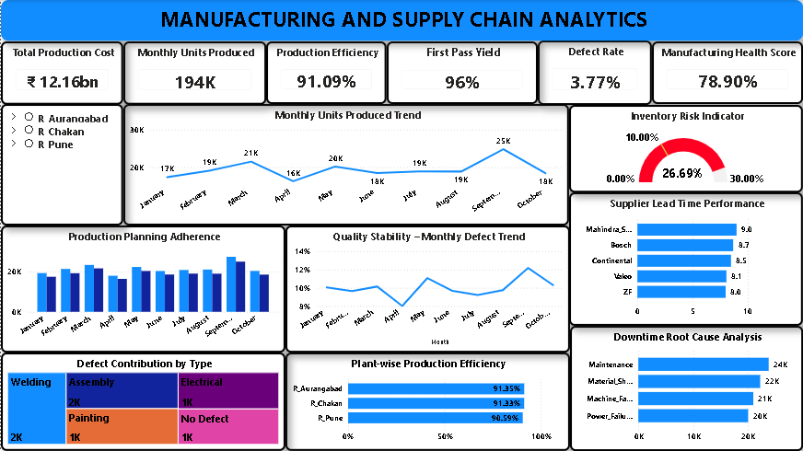

Executive KPIs
- Total Production Cost
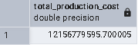
- Monthly Units Produced
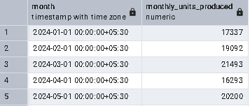

- Production Efficiency (%)
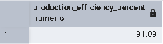
- First Pass Yield (%)
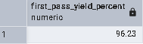
- Defect Rate (%)
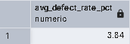
- Manufacturing Health Score (%)
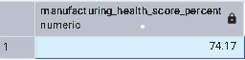

Trend Analysis
- Monthly Units Produced
- Monthly Defect Trend
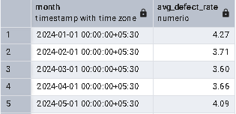

Comparative Analysis
- Planned vs. Actual Production
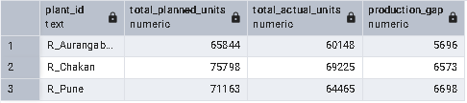

- Plant-wise Production Efficiency
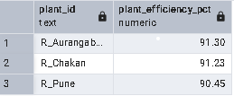
- Supplier Lead Time Performance
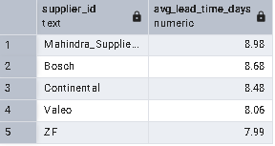

Risk & Quality Analysis
- Inventory Risk Indicator
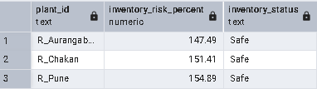
- Defect Contribution by Type
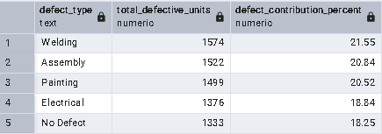
- Downtime Root Cause Analysis
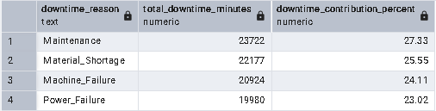

7. Key Insights
- Inventory risk is critical at 26.69%, indicating excess stock exposure and potential working capital inefficiencies.
- Production efficiency remains stable across plants (~91%) but defect rates increase during peak production months.
- Maintenance and material shortages contribute most to downtime.
- Supplier lead time variability introduces delivery risk to production schedules.

8. Business Recommendations
- Inventory Optimization
  - Implement reorder-point-based inventory planning to reduce excess stock and improve working capital efficiency.
- Preventive Maintenance
  - Focus on maintenance-related downtime reduction.
- Supplier Performance Monitoring
  - Prioritize suppliers with consistently lower lead time variance.
- Quality Improvement
  - Target welding and assembly defect reduction initiatives.

9. Tools & Technologies
- PostgreSQL
- Python (pandas, numpy)
- Power BI
- DAX
- SQL
- Google Sheet (Data Validation)

10. Conclusion

This project demonstrates how a structured data analytics approach can transform raw manufacturing and supply chain data into a decision-support system for operational excellence. By integrating production, quality, inventory, downtime, and supplier metrics into a unified analytical model, the dashboard enables stakeholders to monitor plant performance in real time, identify operational risks early, and prioritize improvement initiatives with measurable impact.
The insights derived—such as production efficiency trends, defect contribution patterns, inventory risk levels, and downtime root causes—support data-driven planning, quality improvement, and cost optimization, which are critical for large-scale automotive manufacturing environments.
Overall, this project reflects how analytics can move beyond reporting to become a strategic enabler, empowering manufacturing leaders to improve efficiency, enhance product quality, strengthen supply chain reliability, and support continuous improvement across operations.

